HOW TO COMPLETE 2018 VM BID SHEET(S)

- Forms are available at the following https://mobi.southernco.com/APC_PDCS_PreBid/Home
- You may complete these bid forms in excel by entering your rate for jobs you’re interested in bidding in the “Price per Mile” cell. The entire spreadsheet is locked except those cell(s). See Image 1
- Each job will print out on a separate sheet of paper. Some jobs are large and will print on multiple pages, ensure your bid sheets are complete.
- You may print all bid forms for all jobs and mail the completed sheets to Maxine Moore at:
Alabama Power Company
Attn: Maxine Moore
600 18th Street, North
Bin: 2S-0704
Birmingham, AL 35291
- Bid sheets must be sent in a sealed envelope and received by Maxine Moore by September 7th, 2018.
- All questions are to be submitted through the MOBI site. Please ensure you check the MOBI site routinely for any answers to questions that are received.

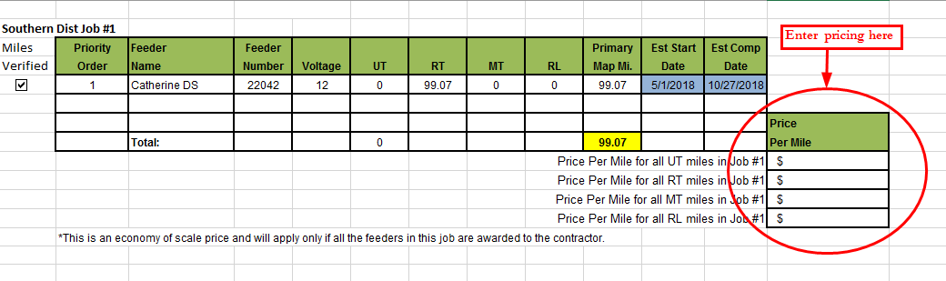
Image 1 ↑

